**Assignment No. 3**

**Aim:** Setup a WAN which contains wired as well as wireless LAN by using a packet tracer tool. Demonstrate transfer of a packet from LAN 1 (wired LAN) to LAN2 (Wireless LAN).

**Objectives:**

1. To understand the concept of Wireless Networks.
2. To learn how to set up a Wide Area Network (WAN) and Local Area Network (LAN) in Cisco Packet Tracer Tool.

**Theory:**

**1. Theory about Wireless LAN, wireless protocols and wireless devices**

**1. Wireless LAN (WLAN)**

A **Wireless Local Area Network (WLAN)** is a type of network that allows devices to connect and communicate wirelessly within a limited geographical area. Unlike traditional wired LANs, WLANs use radio waves for data transmission, eliminating the need for physical cables. WLANs are commonly used in homes, offices, schools, and public spaces to provide internet access and network connectivity.

**1.1 Components of WLAN**

A typical WLAN consists of the following components:

* **Access Points (APs):** Devices that transmit and receive wireless signals, enabling communication between wireless clients and a wired network.
* **Wireless Clients:** Laptops, smartphones, tablets, and other devices that connect to the WLAN.
* **Wireless Network Interface Cards (NICs):** Hardware installed in devices to enable wireless communication.
* **Router:** Manages network traffic and provides internet connectivity.

**1.2 Advantages of WLAN**

* Provides **mobility** and flexibility.
* Reduces the need for physical cabling, lowering installation costs.
* Supports easy network expansion.
* Enables access to the internet and resources from anywhere within the coverage area.

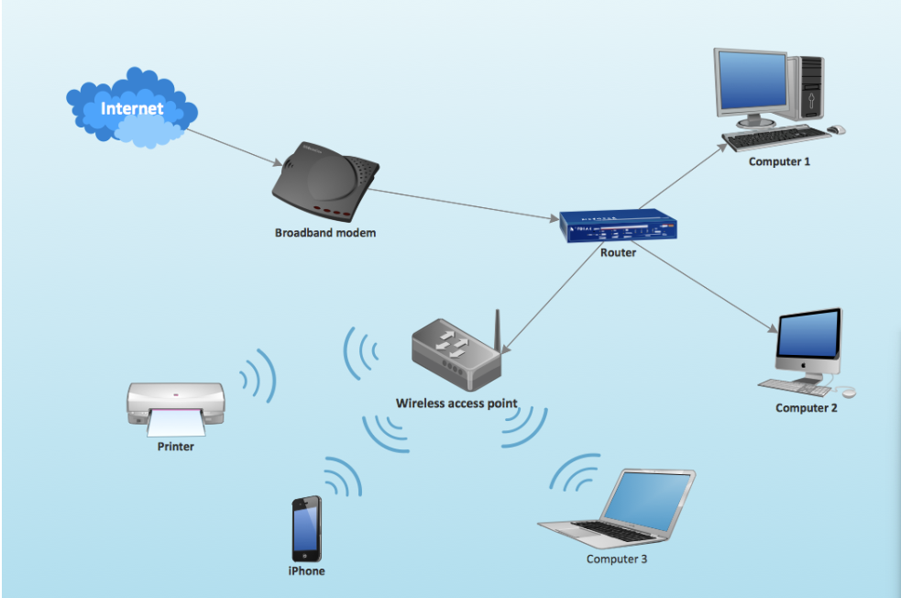

**2. Wireless Protocols**

Wireless communication follows specific standards and protocols to ensure reliable and secure data transmission. The most commonly used wireless protocols include:

**2.1 IEEE 802.11 Standards (Wi-Fi)**

The **IEEE 802.11 family** defines the standards for wireless networking. Some important versions include:

* **802.11a:** Operates at **5 GHz** with a maximum speed of **54 Mbps**.
* **802.11b:** Operates at **2.4 GHz** with a speed of **11 Mbps**.
* **802.11g:** Operates at **2.4 GHz** and supports speeds up to **54 Mbps**.
* **802.11n:** Supports both **2.4 GHz and 5 GHz**, with speeds up to **600 Mbps**.
* **802.11ac:** Operates at **5 GHz**, offering speeds over **1 Gbps**.
* **802.11ax (Wi-Fi 6):** Improves speed, efficiency, and capacity for modern networks.

**2.2 Bluetooth (IEEE 802.15.1)**

Bluetooth is a short-range wireless communication protocol used for exchanging data over short distances (up to 100 meters). It is commonly used in wireless headphones, smartwatches, and IoT devices.

**2.3 Zigbee (IEEE 802.15.4)**

Zigbee is designed for low-power, low-data-rate communication, often used in smart homes, industrial automation, and IoT applications.

**2.4 Infrared (IrDA)**

Infrared communication is a short-range technology used in remote controls, printers, and older mobile devices. It requires a direct line of sight between devices.

**2.5 Near Field Communication (NFC)**

NFC is a wireless protocol that enables close-range communication (within 4 cm). It is widely used for contactless payments and access control.

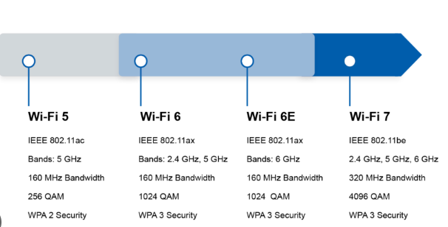

**3. Wireless Devices**

Wireless networks rely on various devices for communication and connectivity. Some of the key wireless devices include:

**3.1 Wireless Routers**

A **wireless router** connects a local network to the internet and provides Wi-Fi connectivity. It includes a built-in access point and supports multiple devices.

**3.2 Access Points (APs)**

Wireless **access points** extend network coverage by providing Wi-Fi connectivity to devices. They are commonly used in offices, hotels, and large buildings.

**3.3 Wireless Network Adapters**

These are hardware components (internal or external) that enable a device to connect to a wireless network. Examples include USB Wi-Fi adapters and built-in Wi-Fi cards.

**3.4 Mobile Hotspots**

A mobile hotspot allows wireless devices to connect to the internet via cellular networks (3G, 4G, or 5G). It is commonly used for portable internet access.

**3.5 Wireless Extenders/Repeaters**

Wireless extenders help expand the range of a WLAN by amplifying the existing Wi-Fi signal.

**3.6 IoT Devices**

Many smart home devices, such as smart speakers, security cameras, and smart thermostats, rely on wireless networks for communication and remote control.

**2.Configurations:**

**1.End Devices(PCs,Laptops,Printers,Smartphones):**

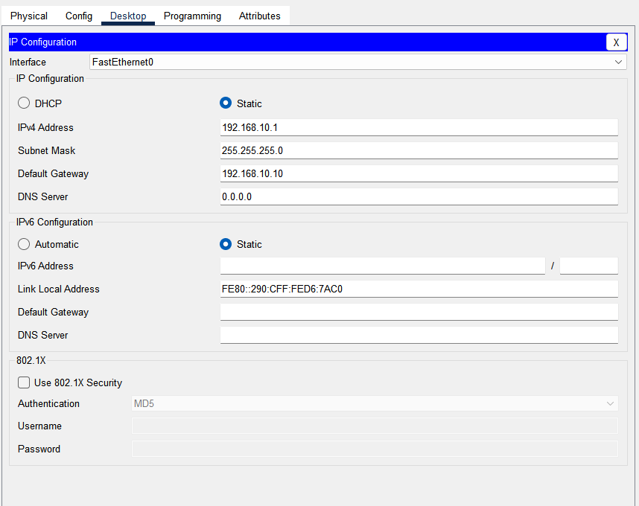

**1. Interface: FastEthernet0**

* The device is connected via a Fast Ethernet interface.

**2. IPv4 Configuration**

* Static IP: The device is manually assigned an IP address instead of obtaining one dynamically via DHCP.
* IPv4 Address: 192.168.10.1 (A private IP address within the 192.168.10.0/24 subnet).
* Subnet Mask: 255.255.255.0 (Indicates a network with a range of 192.168.10.1 to 192.168.10.254).
* Default Gateway: 192.168.10.10 (The router or gateway that connects this network to other networks).
* DNS Server: 0.0.0.0 (Indicates that no DNS server is specified, so name resolution might not work).

1. **Routers**

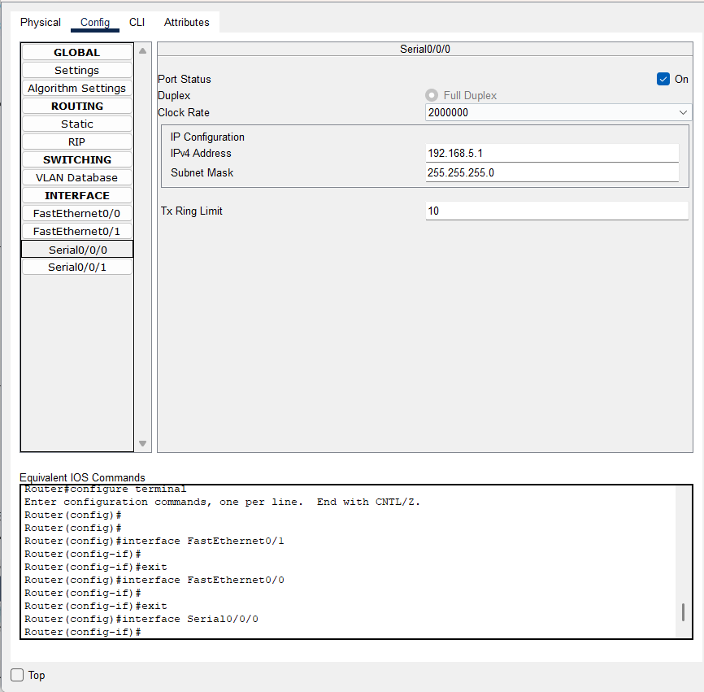

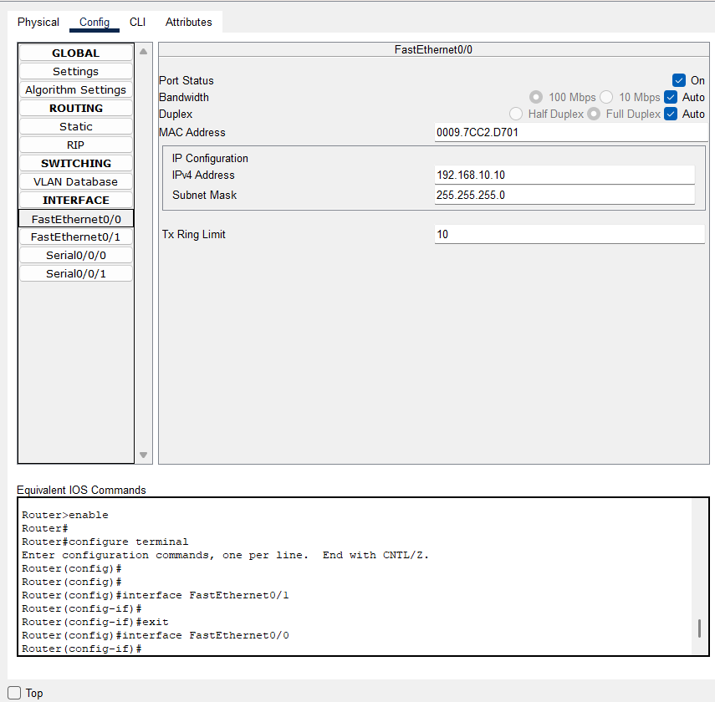

**1. Serial Interface Configuration (Serial0/0/0)**

* Port Status: Enabled (On)
* Duplex: Full Duplex
* Clock Rate: 2000000 (Applicable to DCE end of the serial connection)
* IPv4 Address: 192.168.5.1
* Subnet Mask: 255.255.255.0 (Class A Network)
* Tx Ring Limit: 10 (Determines the transmission queue buffer)

This configuration is typically used for WAN (Wide Area Network) connections between routers.

**2. Fast Ethernet Interface Configuration (FastEthernet0/0)**

* Port Status: Enabled (On)
* Bandwidth: Auto (Negotiates speed)
* Duplex: Auto (Negotiates full/half-duplex mode)
* MAC Address: 0007.ECAD.3E01 (Unique identifier for the interface)
* IPv4 Address: 192.168.10.10
* Subnet Mask: 255.255.255.0 (Class C Network)
* Tx Ring Limit: 10 (Transmission buffer)

**3.Access Points:**

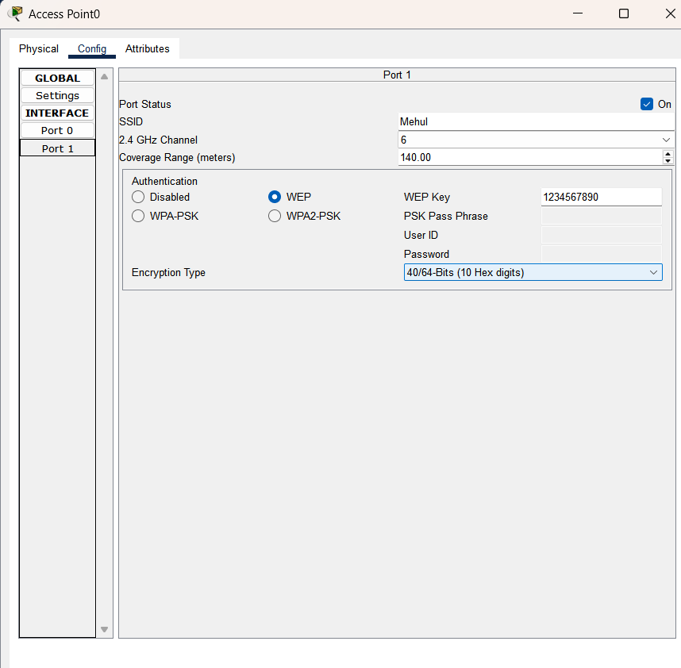

**1. General Wireless Configuration**

Port Status: ✅ Enabled (On)

SSID (Service Set Identifier): Mehul

This is the Wi-Fi network name that clients will connect to.

2.4 GHz Channel: 6

The AP is operating on channel 6 within the 2.4 GHz frequency band.

Coverage Range: 140 meters

Determines how far the Wi-Fi signal extends.

**2. Security and Authentication**

Authentication Type: WEP (Wired Equivalent Privacy)

This is an outdated and weak security protocol. Modern networks typically use WPA2-PSK or WPA3.

WEP Key: 1234567890

This is the network password (a 10-digit hex key for encryption).

Encryption Type: 40/64-bit (10 Hex digits)

Defines the level of encryption applied to transmitted data.

Network Role of the Access Point

The AP serves as a bridge between wireless devices (like laptops, smartphones) and the wired network.

Clients connecting to SSID "Access1" must enter the WEP key 1234567890 to access the network.

Using WEP is insecure; upgrading to WPA2-PSK is recommended to enhance security.

**Addressing Table/Routing Table:**

**For Router 1:**

|  |  |  |  |
| --- | --- | --- | --- |
| Destination Network | Subnet Mask | Next Hop | Interface |
| 192.168.4.0 | 255.255.255.0 | 192.168.7.2 | Serial1/0 |
| 192.168.6.0 | 255.255.255.0 | 192.168.7.2 | Serial1/0 |
| 192.168.2.0 | 255.255.255.0 | 192.168.7.2 | Serial1/0 |
| 192.168.1.0 | 255.255.255.0 | 192.168.12.1 | Serial0/0 |
| 192.168.10.0 | 255.255.255.0 | 192.168.12.1 | Serial0/0 |

**For Router 2:**

|  |  |  |  |
| --- | --- | --- | --- |
| Destination Network | Subnet Mask | Next Hop | Interface |
| 192.168.10.0 | 255.255.255.0 | 192.168.7.1 | Serial0/0 |
| 192.168.1.0 | 255.255.255.0 | 192.168.7.1 | Serial0/0 |
| 192.168.2.0 | 255.255.255.0 | 192.168.8.1 | Serial1/0 |
| 192.168.6.0 | 255.255.255.0 | 192.168.8.1 | Serial1/0 |
| 192.168.11.0 | 255.255.255.0 | 192.168.7.1 | Serial0/0 |
| 192.168.13.0 | 255.255.255.0 | 192.168.7.1 | Serial0/0 |

**For Router 3**

|  |  |  |  |
| --- | --- | --- | --- |
| Destination Network | Subnet Mask | Next Hop | Interface |
| 192.168.2.0 | 255.255.255.0 | 192.168.5.2 | Serial0/0 |
| 192.168.6.0 | 255.255.255.0 | 192.168.5.2 | Serial0/0 |
| 192.168.11.0 | 255.255.255.0 | 192.168.12.2 | Serial1/0 |
| 192.168.4.0 | 255.255.255.0 | 192.168.5.2 | Serial0/0 |
| 192.168.13.0 | 255.255.255.0 | 192.168.12.2 | Serial1/0 |

**For Router 4:**

|  |  |  |  |
| --- | --- | --- | --- |
| Destination Network | Subnet Mask | Next Hop | Interface |
| 192.168.10.0 | 255.255.255.0 | 192.168.5.1 | Serial0/0 |
| 192.168.1.0 | 255.255.255.0 | 192.168.5.1 | Serial0/0 |
| 192.168.4.0 | 255.255.255.0 | 192.168.8.2 | Serial1/0 |
| 192.168.11.0 | 255.255.255.0 | 192.168.8.2 | Serial1/0 |
| 192.168.13.0 | 255.255.255.0 | 192.168.8.2 | Serial1/0 |

**1. Information Technology (IT) Department**

|  |  |  |  |  |  |
| --- | --- | --- | --- | --- | --- |
| Device Name | Device Type | IP Address | Subnet Mask | Default Gateway | Interface |
| PC0 | PC | 192.168.1.1 | 255.255.255.0 | 192.168.1.10 | Wireless0 |
| PC1 | PC | 192.168.1.2 | 255.255.255.0 | 192.168.1.10 | Wireless0 |
| Laptop3 | Laptop | 192.168.1.3 | 255.255.255.0 | 192.168.1.10 | Wireless0 |
| PC4 | PC | 192.168.10.2 | 255.255.255.0 | 192.168.10.10 | FastEthernet0/0 |
| PC5 | PC | 192.168.10.1 | 255.255.255.0 | 192.168.10.10 | FastEthernet0/0 |
| Laptop4 | Laptop | 192.168.10.3 | 255.255.255.0 | 192.168.10.10 | FastEthernet0/0 |
| Printer2 | Printer | 192.168.10.4 | 255.255.255.0 | 192.168.10.10 | FastEthernet0/0 |

**2. Computer Department**

|  |  |  |  |  |  |
| --- | --- | --- | --- | --- | --- |
| Device Name | Device Type | IP Address | Subnet Mask | Default Gateway | Interface |
| Laptop6 | Laptop | 192.168.13.1 | 255.255.255.0 | 192.168.13.10 | FastEthernet0/0 |
| PC12 | PC | 192.168.13.2 | 255.255.255.0 | 192.168.13.10 | FastEthernet0/0 |
| Printer3 | Printer | 192.168.13.3 | 255.255.255.0 | 192.168.13.10 | FastEthernet0/0 |
| PC9 | PC | 192.168.11.1 | 255.255.255.0 | 192.168.11.10 | Wireless0 |
| PC10 | PC | 192.168.11.2 | 255.255.255.0 | 192.168.11.10 | Wireless0 |
| PC11 | PC | 192.168.11.3 | 255.255.255.0 | 192.168.11.10 | Wireless0 |

**3. AIML Department**

|  |  |  |  |  |  |
| --- | --- | --- | --- | --- | --- |
| Device Name | Device Type | IP Address | Subnet Mask | Default Gateway | Interface |
| PC8 | PC | 192.168.6.1 | 255.255.255.0 | 192.168.6.10 | FastEthernet0/0 |
| Server0 | Server | 192.168.6.2 | 255.255.255.0 | 192.168.6.10 | FastEthernet0/0 |
| Laptop5 | Laptop | 192.168.6.3 | 255.255.255.0 | 192.168.6.10 | FastEthernet0/0 |
| Printer1 | Printer | 192.168.2.4 | 255.255.255.0 | 192.168.2.10 | FastEthernet0/0 |
| PC2 | PC | 192.168.2.1 | 255.255.255.0 | 192.168.2.10 | FastEthernet0/0 |
| PC3 | PC | 192.168.2.2 | 255.255.255.0 | 192.168.2.10 | FastEthernet0/0 |
| Laptop1 | Laptop | 192.168.2.3 | 255.255.255.0 | 192.168.2.10 | FastEthernet0/0 |

**4.Mechanical Department**

|  |  |  |  |  |  |
| --- | --- | --- | --- | --- | --- |
| Device Name | Device Type | IP Address | Subnet Mask | Default Gateway | Interface |
| PC13 | PC | 192.168.4.1 | 255.255.255.0 | 192.168.4.10 | FastEthernet0/0 |
| PC14 | PC | 192.168.4.2 | 255.255.255.0 | 192.168.4.10 | FastEthernet0/0 |
| Laptop0 | Laptop | 192.168.4.3 | 255.255.255.0 | 192.168.4.10 | FastEthernet0/0 |
| Laptop2 | Laptop | 192.168.4.4 | 255.255.255.0 | 192.168.4.10 | FastEthernet0/0 |
| PC6 | PC | 192.168.4.2 | 255.255.255.0 | 192.168.4.10 | FastEthernet0/0 |
| PC7 | PC | 192.168.4.5 | 255.255.255.0 | 192.168.4.10 | FastEthernet0/0 |
| Server1 | Server | 192.168.4.6 | 255.255.255.0 | 192.168.4.10 | FastEthernet0/0 |
| Printer0 | Printer | 192.168.4.4 | 255.255.255.0 | 192.168.4.10 | FastEthernet0/0 |

**5.Admin Office**

|  |  |  |  |  |  |
| --- | --- | --- | --- | --- | --- |
| Device Name | Device Type | IP Address | Subnet Mask | Default Gateway | Interface |
| PC15 | PC | 192.168.14.1 | 255.255.255.0 | 192.168.4.10 | Wireless0 |
| Smartphone0 | Smartphone | 192.168.14.3 | 255.255.255.0 | 192.168.4.10 | Wireless0 |
| Laptop7 | Laptop | 192.168.14.2 | 255.255.255.0 | 192.168.4.10 | Wireless0 |

**3.Output**

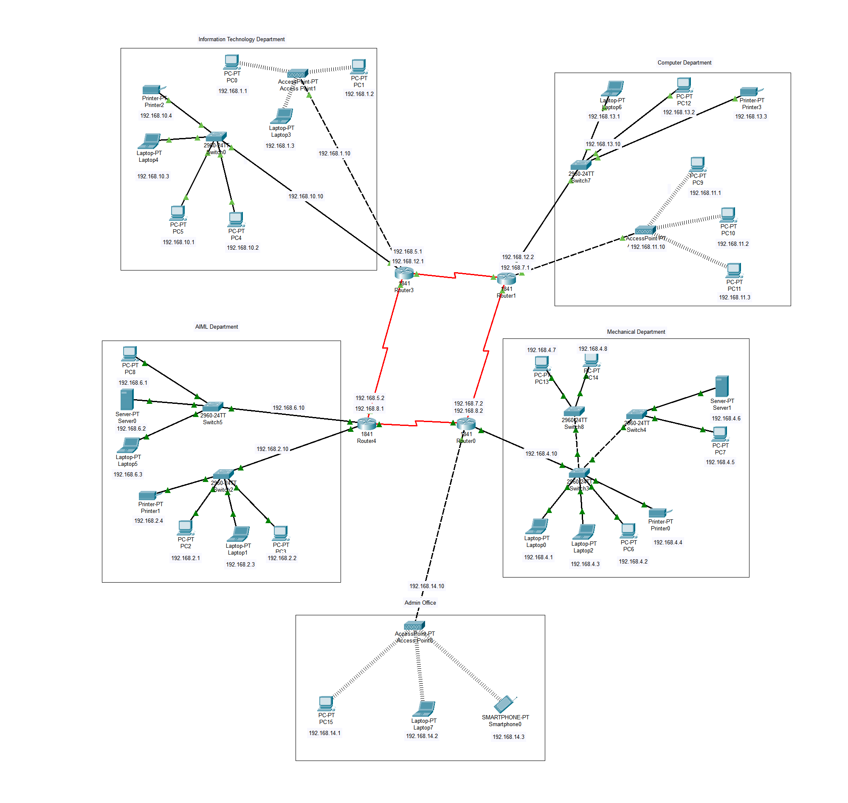

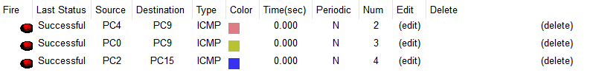

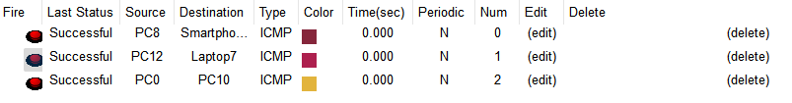

**4. Conclusion:**

In this assignment, we successfully implemented a WAN containing both wired and wireless LANs using Cisco Packet Tracer. We demonstrated the transfer of data between wired and wireless networks, reinforcing the concepts of network protocols, wireless connectivity, and communication between different network types.